Simple Show & Hide Checklists

This is for a simple checklist where a group of items are based on a True or False statement.

Setup one column with FALSE on the row you want to have as the section header

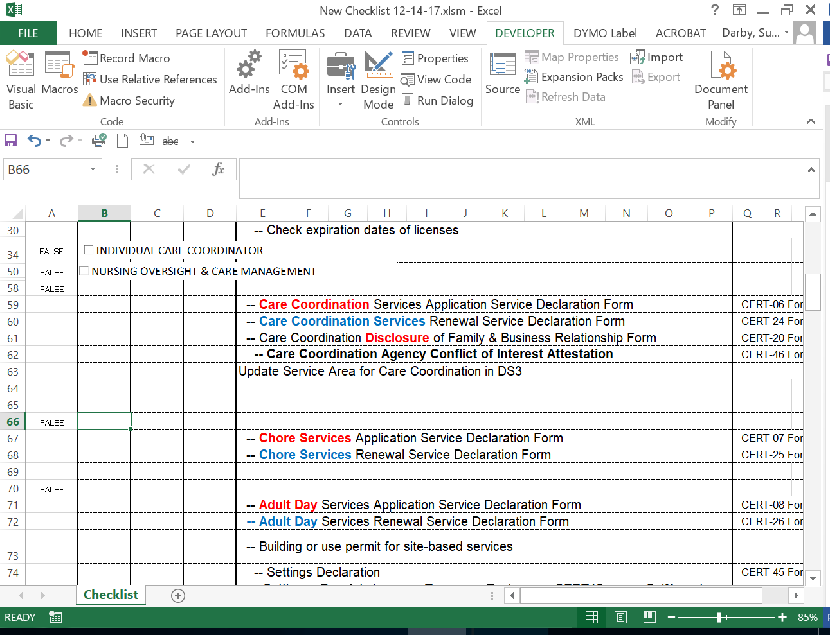

On the Developer Toolbar click Design Mode

Still on the Developer Toolbar click Insert > Active X Control and choose the checkbox

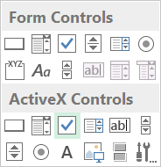

Draw your checkbox where desired

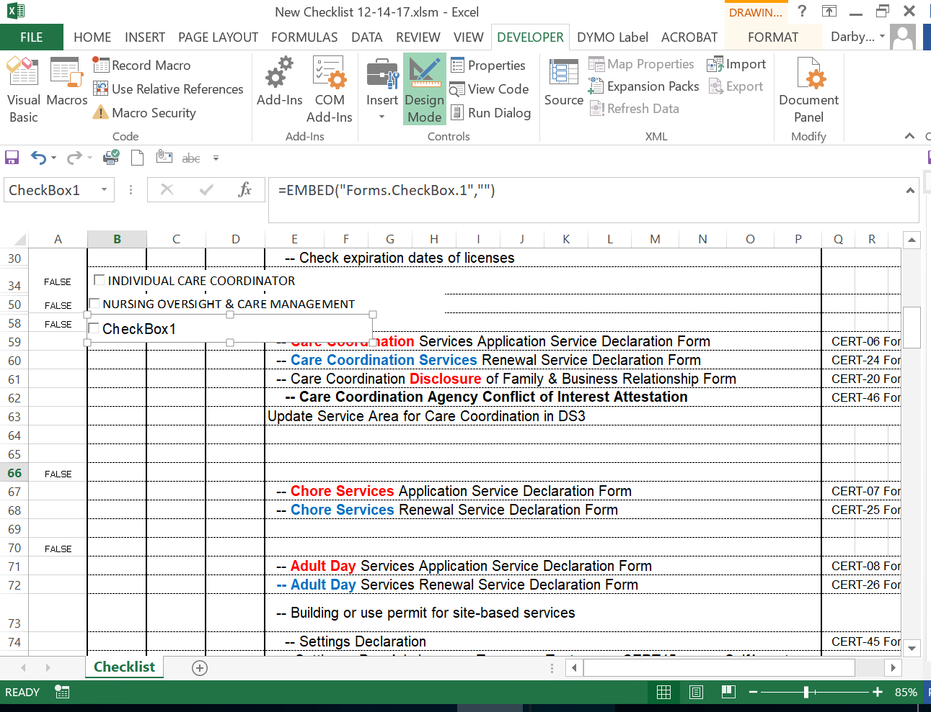

Right click on the checkbox and go to Properties

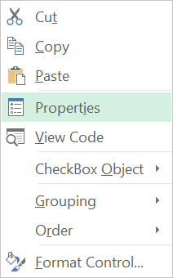

Name your checkbox and add your caption

In the linked cell add a $<column>$<row> absolute link, i.e. $A$58 this tells the macro where to look to perform the code you are about to program.

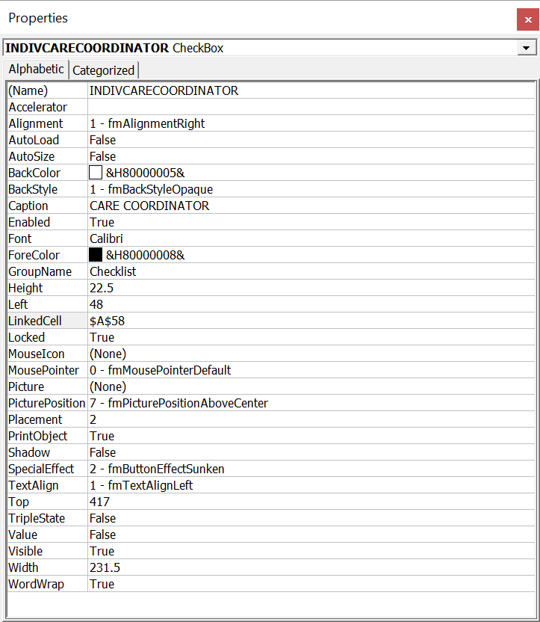

You can also adjust the font and font size, color etc in this dialog so that it matches the rest of the project

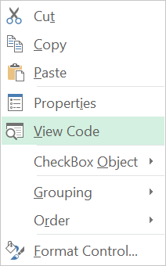

Right click on the checkbox and go to View Code

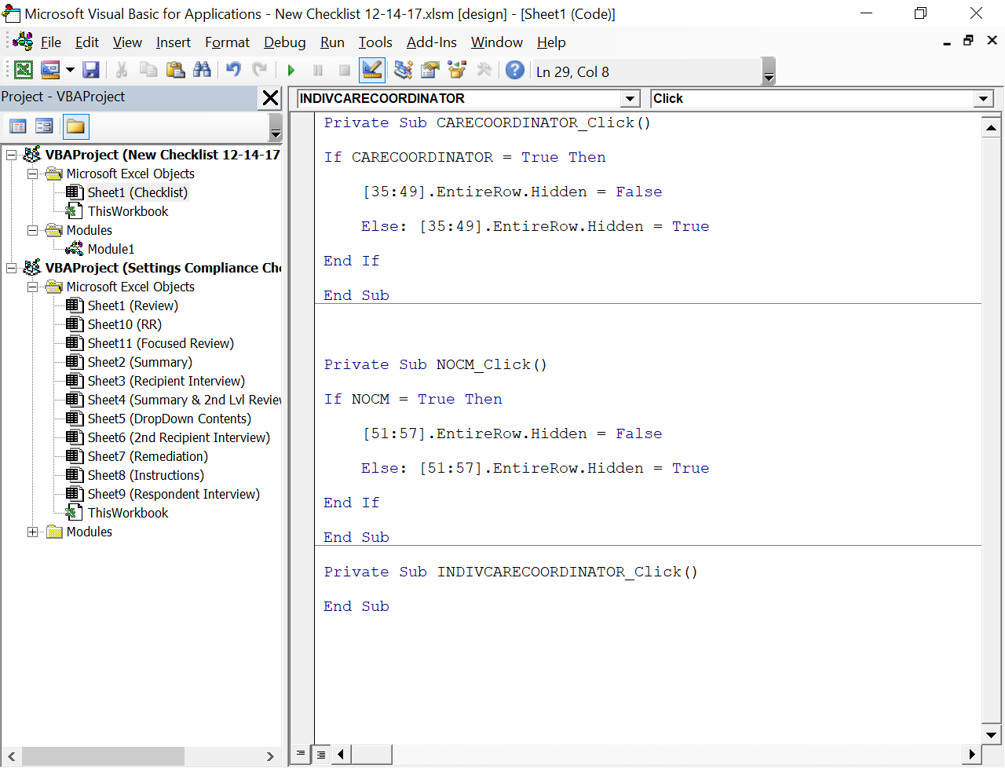

Based on the basic premise of If → Then → Else you can reuse the code to create the new function code

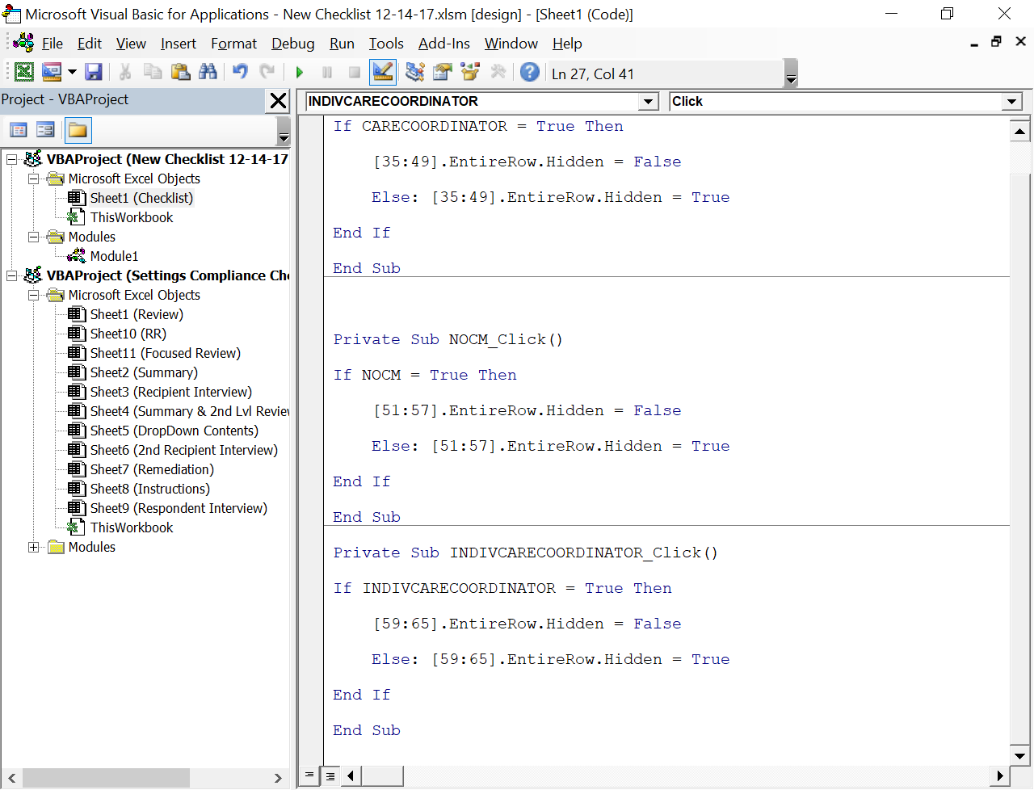

Use the first part of the Private Sub to fill in the IF portion of the statement

Change the numbers to show what lines you want to show and hide.

Notes:

There are extra lines between sections to easily add new items

Adding a new line aka INSERTING a whole new row WILL require a recalculation of the show & hides of everything below! You can add new lines to the Common Requirements downward at will.